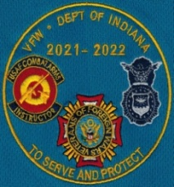
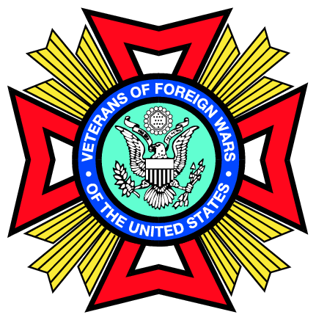
VFW STATE COMMANDER – DICK LINEBERRY
2021-2022 STATE SHIRT
POLO, LONG SLEEVE OR SHORT SLEEVE DENIM SHIRT
Order Deadlines:
Orders MUST be received by these deadlines to be delivered at State Conference Events.
Your order will be placed on the closest deadline after it is received.
Mar 29th (to receive at Convention), June 4th (to receive at School), Aug. 10th (to receive at Fall)
No orders will be accepted after Aug. 10^{h}

Name: Phone: Post:______
Address:
All shirts and sweatshirts will have Dick’s Logo

Turquoise Men’s or Ladies Polo (No Pocket).
Small to XL - $30.00 2XL - $31.00 3XL - $34.00 4XL - $35.00 5XL - $37.00
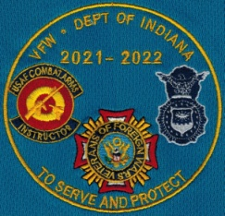
Men/Ladies Size Quantity Total $
Denim Short or Long Sleeve faded blue Men’s or Ladies
Small to XL - $30.00 2XL - $31.00 3XL - $34.00 4XL - $35.00
Men/Ladies Size Quantity Total $
Zip Up Hoodie – Carolina Blue – Men’s Sizes Only
Sweatshirts: Small to XL - $30.00 2XL - $39.00 3XL - $40.00 4XL - $42.00 5XL - $43.00
Size Quantity Total $
Name and VFW Office Embroidered on right chest
(If you do NOT want right chest embroidered, subtract $4.00 from the cost of each shirt.)
Name
Title
Post/AUX OR Branch of Service
Branch of Service will NOT be on sleeve.

Please make checks payable to VFW Department of Indiana
Sub-Total $ Accepting All forms of Payment
Shipping Fee $8.00 (up to 3 shirts or 2 sweatshirts) For questions please call State HQ @ 317-377-1795
Shipping $ For Credit Cards, include
Total $ Number, Exp Date, and CCV
Code. (3 digits)
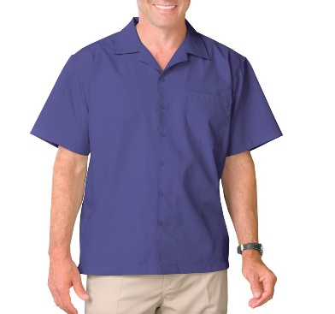
Mail Orders to: Fax Orders to: (317)377-1797
VFW Dept. of Indiana
9555 E. 59th St. E-Mail Orders:
Indpls., IN 46216 adj@vfwin.org

