VFW State Commander – Sheila Corcoran

2023-2024 Shirt Order Form

Polo – Full Zip Up Hoodie - Oxford

Orders must be received at HQ by these deadlines to be delivered at the event.

Ordered by April 7th – available at State Convention

Ordered by May 26th – available at National Convention or SOI Ordered by Aug 21th – LAST ORDER – available at Fall Conference

Name Phone Post #

Commanders Shirt Logo

Address

Polos, Full Zip Up Hoodie, Oxford will have Commanders Logo

Royal/Black Men’s or Ladies Polo (no pocket – wicking material) (Ladies polo runs small)

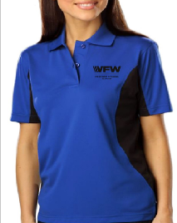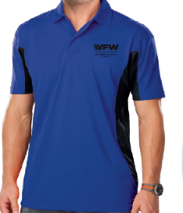Small to XL - $31 2XL - $33 3XL - $35 4XL - $37 5XL - $38

Men’s/Ladies Size Quantity Total $

|  |  |  |  |
| --- | --- | --- | --- |
|  |  |  |  |

Ash-Gray Men’s Full Zip Up Hoodie

Small to XL - $34 2XL - $40 3XL - $45

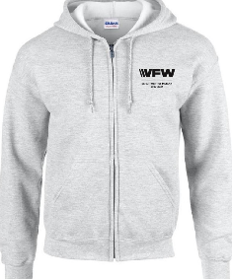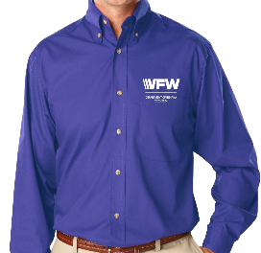Men’s Size Quantity Total $

|  |  |  |  |
| --- | --- | --- | --- |
|  |  |  |  |

French Blue Men’s or Ladies Oxford long sleeve Wrinkle-Resistant Small to XL - $35 2XL - $36 3XL - $37 4XL - $39 5XL - $42

Men’s/Ladies Size Quantity Total $

|  |  |  |  |
| --- | --- | --- | --- |
|  |  |  |  |

Name, VFW title, Post/Aux or Branch of Service embroidered on right chest. No embroidery on right chest subtract $4.00

Line #1 NAME Line #2 TITLE Line #3 POST/AUX/BOS

Line #4 POST/AUX/BOS

TOTAL

NO shipping cost unless you want shirts shipped other than VFW HQ! $

Shipping for 3 shirts $8.00 – Any questions call HQ 317-377-1795

SHIPPING $ =

GRAND TOTAL $ =

MAKE CHECKS PAYABLE TO:

**VFW Dept of Indiana**

Payment with Credit Card

Name on Card: Expiration Date

Card Number: CCV Code (3 digits)

Mail Orders To: FAX Orders to: Email Orders to: VFW Dept of Indiana 317-377-1797 [adj@vfwin.org](mailto:adj@vfwin.org) 9555 E. 59th Street

Indianapolis, IN 46216 Question please email [adj@vfwin.org](mailto:adj@vfwin.org) or call 317-377-1795